Hardware Installation Guide

The Operations Team must follow the steps below

PRE-INSTALLATION:
- Technical Reconnaissance (scope site layout & choose cabinet locations)
- Plan the project (time-line, project lead, components needed, etc)
- Start a hardware requisition
- Order materials/components
- Reconcile procurement of materials with project needs
- Modify exiting hardware:
  - Cabinet
- Drilling and mounting of fans
  - Fan 1 Should be browing inside
  - Fan 2 Should be browing out
  - Fan 3 Should be browing inside
- Add block board to Power and server cabinets covering the entire interior back wall of the cabinet
- Wiring of the carbinet
  - Installation of battery cables
  - installation of wire to the fans
- Install Double surface Socket, AVS, AC cables to the main Switch
- Drill possitions for Charger, LVD.

  - Power Socket
- Drill holes for speakon connectors
- Soldering and mounting of speakon connectors
  - Speakon connector should be mounted the side of the one gang switch two way switch.

HOW TO CHOOSE CABINET LOCATIONS:

- Pick a central location for the Switchboard:
- Distance between cabinet & workstations should not be > 90m
- If distance between any 2 points exceed 90m add another switch cabinet



Switch
Cabinet

- Choose a central location for the Server Cabinet:
- Needs to be in a well ventilated room, at least a window
- Room needs to be secure: windows with bars and door with locks

- Choose a well ventilated area for the Power cabinet:
- For J2's are more than 10 workstations add one more power cabinet Power Cabinet (a full back up system with 4 batteries)

CABINET DESIGNS:

Standard Design = 2 cabinets.
1
2

Power + (Switch and Server)

Alternative Design = 3 cabinets.

1
2
3

Power + Server + Switch

CABINET LAYOUT

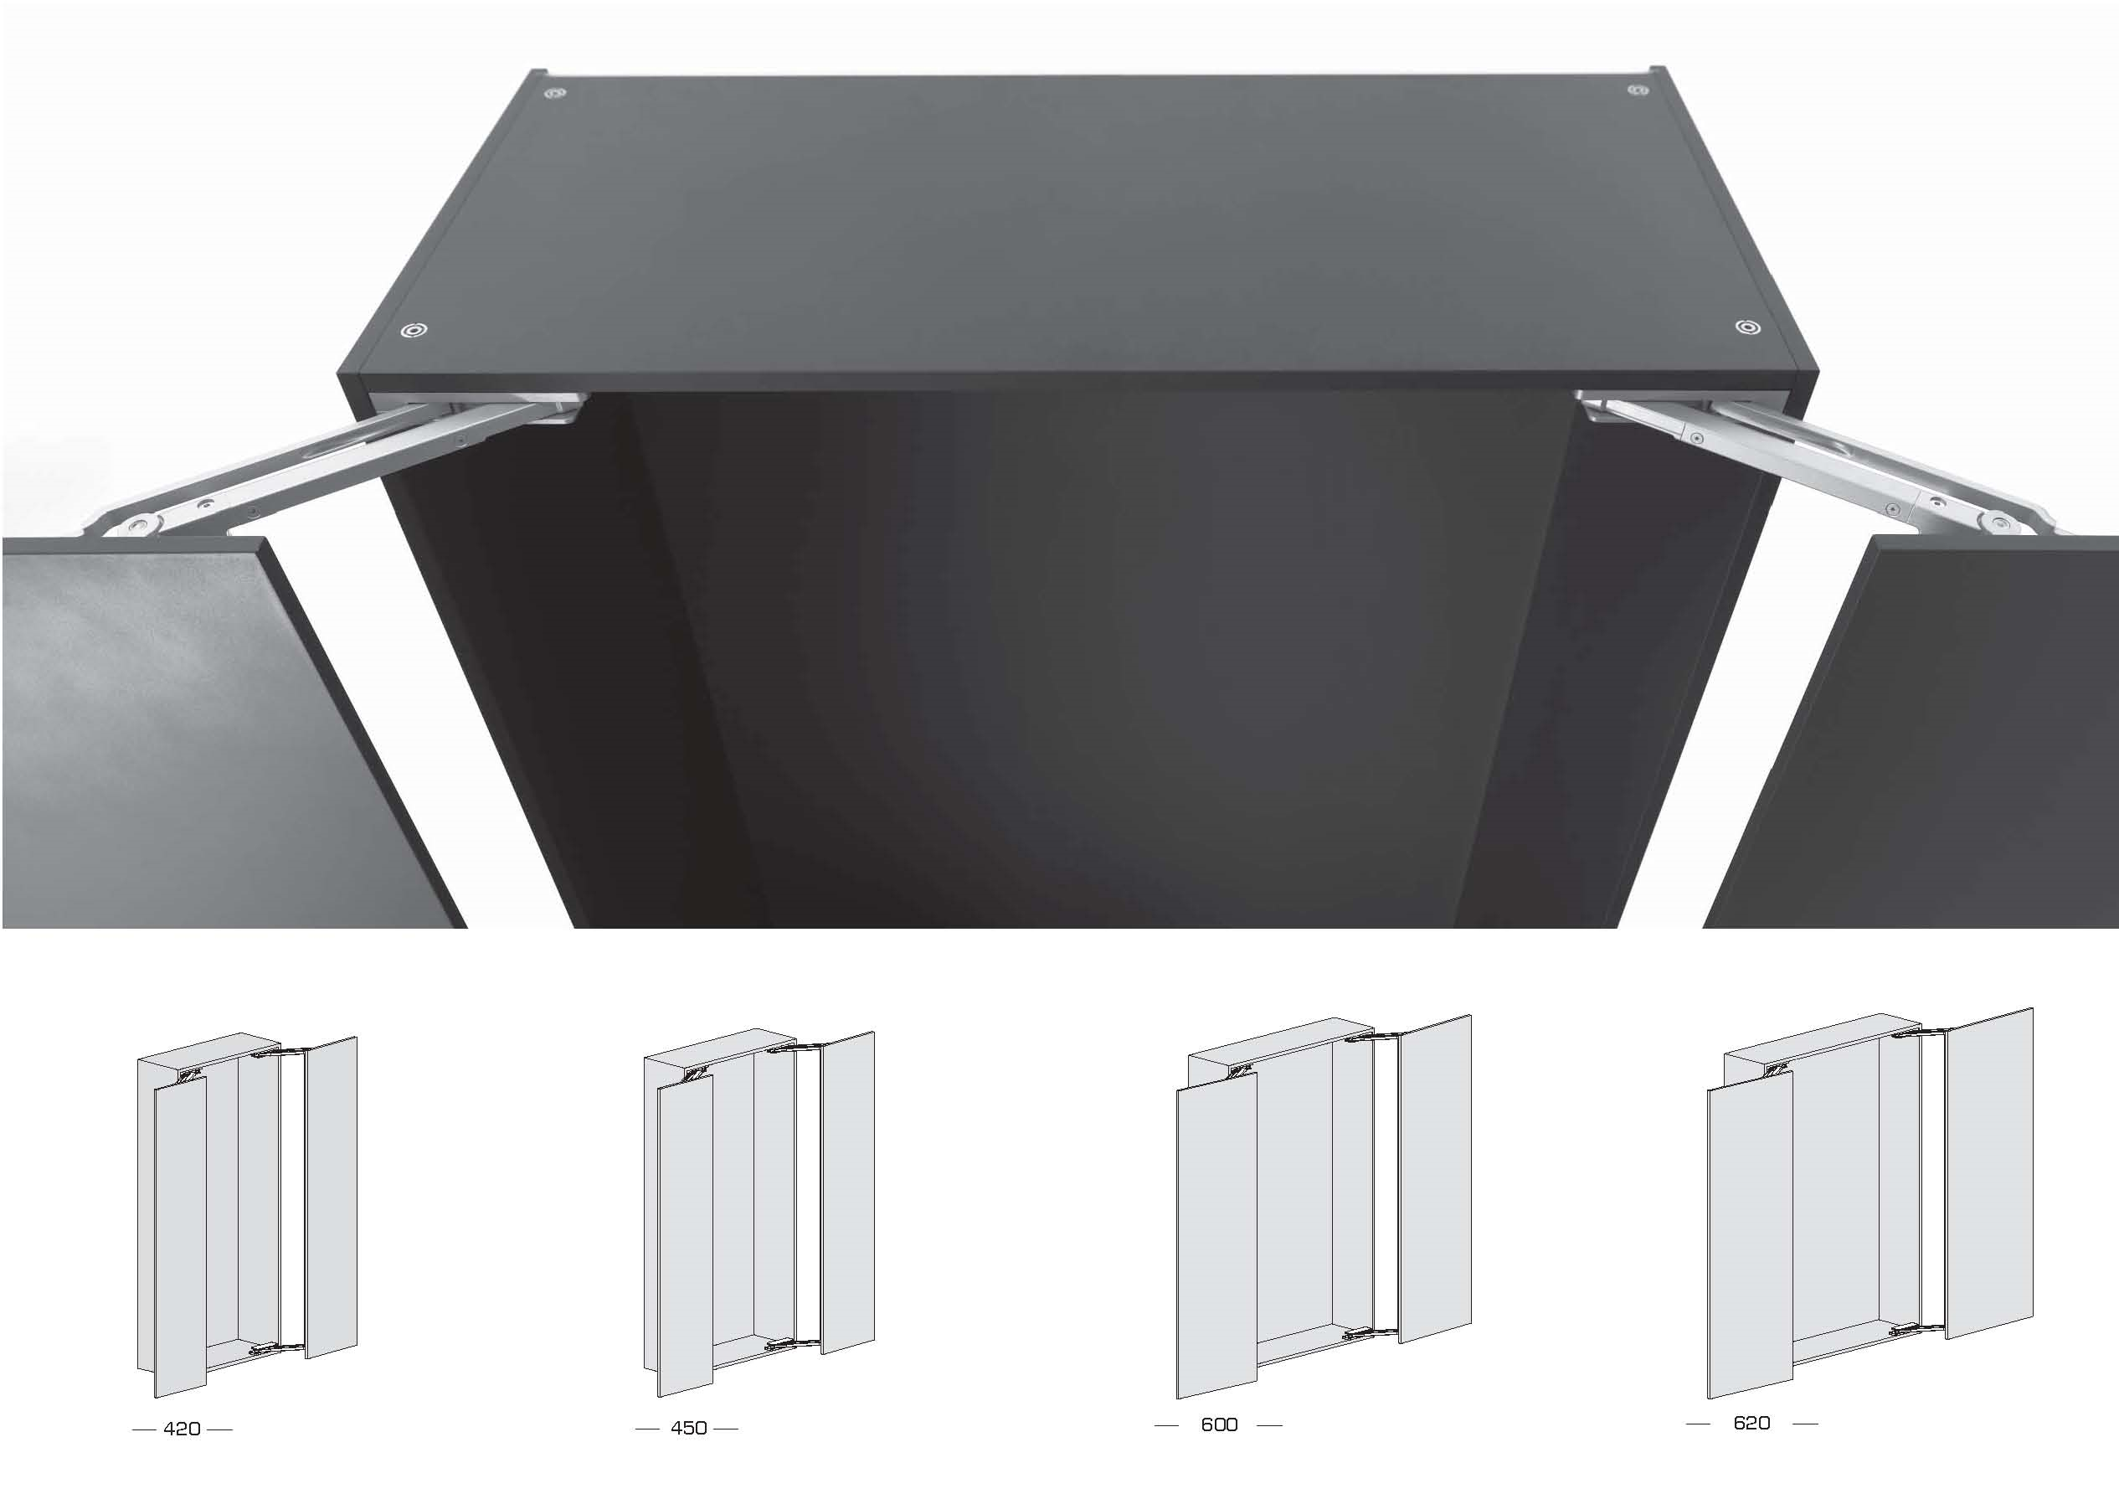

NOT

Correct Incorrect

STANDARD DESIGN
All cabinets in different rooms: see below

Switch + Server + Power
3
Server
Fan(air out)
LVD
Charger
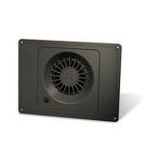
Power Connections

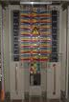
Shelf
Switch
4 Batteries
Power Connections
1
2
Voltage Monitor
Fan(air out)
Blockboard
Blockboard
Fan(air in)
Fan(air out)
Blockboard

ALTERNATIVE DESIGN

Server & Switch in the same cabinet stacked vertically on top of the Power Cabinet: see below
Server
Switch
Fan(air out)
+
Blockboard
1
Switchboard & Server
Power Connections
2
Voltage Monitor
Blockboard
Fan (air out)
LVD
3
Charger)
4 Batteries
Shelf
Power
Fan (air in)
Fan (air out)
Blockboard

DAY OF INSTALLATION

Should be done prior to Back Data Entry by Support & Deployment Team

Alternative Back Data Entry:The Support & Deployment Team connects touch-screens to a local server and ESCOM electricity, with a working hospital generator or Baobab generator, then migrate data later.

PRIOR TO DEPARTURE:
Use the “Hardware Check-list” to confirm you have all materials needed to bring to the site.

Stage 1: RUN WIRES & PIPES

- Install of cabinets
- Power
  - Should be centered in the room where installed wherever possible
- Server
  - Should be installed on top of the power cabinet
  - Incase there are in different locations with the power cabinet then it should be installed 1.5m from the ground
- Switch
  - Should be installed 2m from ground

Stage 2: INSTALL CABINETS
- Install PVC pipe for power and network cables
- Install PVC trunking
- Installation of power and data sockets
Should be installed at 250cm from the ground

Stage 3:
- Pulling cables
- Terminate Ethernet cables

Stage 3: TEST

- Test Power Connections with volt multimeter to make sure 48 volts are coming from each power socket.

- Test Connectivity- (i.e. “ping” server IP addresses). Test point of care at each station.

- Test connectivity between Baobab system & HMIS office (i.e. “ping” server IP address)

- If site has internet, configure Baobab server on site to access Baobab HQ network.

SECURITY & SAFETY: FINAL CHECK

- All cabinets must have a padlock
- Padlocks should have short locking hook.
- All rooms must be locked
- Label keys: 1 set of with HMIS Officer & 1 set at Baobab HQ in Operations Department key cabinet
- Every room with a power cabinet needs to have a fire extinguisher

OPERATIONS HARDWARE CHECKLIST | CHECK LIST FOR NEW SITE HW INSTALLATION
OPERATIONS HARDWARE CHECKLIST | TOOLS/ MATERIALS REQUIRED | QTY | CHECK
OPERATIONS HARDWARE CHECKLIST | Keys for server room & cabinets
OPERATIONS HARDWARE CHECKLIST | 2.5mm earth wire
OPERATIONS HARDWARE CHECKLIST | 48V cooling fan
OPERATIONS HARDWARE CHECKLIST | Babble level
OPERATIONS HARDWARE CHECKLIST | Batteries
OPERATIONS HARDWARE CHECKLIST | Battery Charger
OPERATIONS HARDWARE CHECKLIST | Battery Charger for drill machine
OPERATIONS HARDWARE CHECKLIST | Battery terminals
OPERATIONS HARDWARE CHECKLIST | Circuit Breaker
OPERATIONS HARDWARE CHECKLIST | server
OPERATIONS HARDWARE CHECKLIST | Drill bits ( concrete, steel, wood bits)
OPERATIONS HARDWARE CHECKLIST | Drill machines (both electric & battery power)
OPERATIONS HARDWARE CHECKLIST | Fish tape
OPERATIONS HARDWARE CHECKLIST | Hacksaw
OPERATIONS HARDWARE CHECKLIST | Hammer
OPERATIONS HARDWARE CHECKLIST | Hydrolic cutting machine
OPERATIONS HARDWARE CHECKLIST | Insulation tape
OPERATIONS HARDWARE CHECKLIST | Ladders
OPERATIONS HARDWARE CHECKLIST | LVD
OPERATIONS HARDWARE CHECKLIST | Multimeter
OPERATIONS HARDWARE CHECKLIST | Network Switch
OPERATIONS HARDWARE CHECKLIST | Padlocks for cabinets
OPERATIONS HARDWARE CHECKLIST | Plain bend
OPERATIONS HARDWARE CHECKLIST | Pliers
OPERATIONS HARDWARE CHECKLIST | Power Extension cord
OPERATIONS HARDWARE CHECKLIST | PVC coupling
OPERATIONS HARDWARE CHECKLIST | PVC Nipples
OPERATIONS HARDWARE CHECKLIST | PVC pipes (25mm,110mm,20mm)
OPERATIONS HARDWARE CHECKLIST | PVC pipes (25mm,110mm,20mm)
OPERATIONS HARDWARE CHECKLIST | PVC saddles
OPERATIONS HARDWARE CHECKLIST | PVC trunking
OPERATIONS HARDWARE CHECKLIST | RJ45 connectors
OPERATIONS HARDWARE CHECKLIST | RJ45 Crimping tool
OPERATIONS HARDWARE CHECKLIST | Router if necessary
OPERATIONS HARDWARE CHECKLIST | Screw drivers
OPERATIONS HARDWARE CHECKLIST | Screws, Nut & bolts
OPERATIONS HARDWARE CHECKLIST | Side Cutters
OPERATIONS HARDWARE CHECKLIST | Soldering station, Solder wire
OPERATIONS HARDWARE CHECKLIST | SW Mounting Bracket
OPERATIONS HARDWARE CHECKLIST | Spanners
OPERATIONS HARDWARE CHECKLIST | Speakon connectors
OPERATIONS HARDWARE CHECKLIST | Spring bender
OPERATIONS HARDWARE CHECKLIST | Surge protector
OPERATIONS HARDWARE CHECKLIST | Tape measure
OPERATIONS HARDWARE CHECKLIST | Torch
OPERATIONS HARDWARE CHECKLIST | Twin surface switch
OPERATIONS HARDWARE CHECKLIST | USB-Serial adapter
OPERATIONS HARDWARE CHECKLIST | Voltage monitor
OPERATIONS HARDWARE CHECKLIST | Water pipe
OPERATIONS HARDWARE CHECKLIST | Work Suit

